Oblique Hexagonal Pyramid
# Source: AI Source: Provided by: [Data Path: Persons Table -> ID Column: 1, Name_En Column: Motasem Essam] -> From: [ChatGPT] on [7/25/2026]
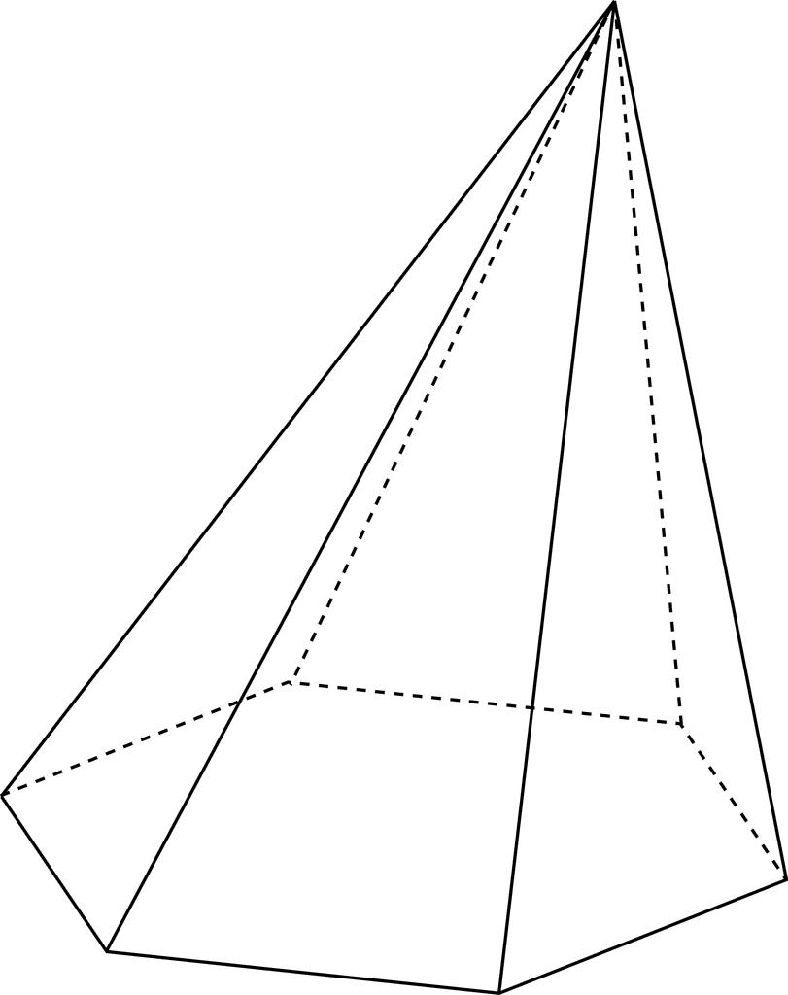

Definition
# Source: AI Source: Provided by: [Data Path: Persons Table -> ID Column: 1, Name_En Column: Motasem Essam] -> From: [ChatGPT] on [7/25/2026]
An oblique hexagonal pyramid is a three-dimensional geometric solid with a hexagonal base and six triangular lateral faces that meet at a single point called the apex. The apex is offset from the designated center of the base, giving the pyramid an inclined appearance.
The perpendicular height is the shortest distance from the apex to the plane of the base. It is different from the sloping lateral edges, which connect the apex to the six base vertices.
An oblique hexagonal pyramid may have a regular or irregular hexagonal base. The term oblique describes the spatial orientation of the pyramid, while regular or irregular describes the base shape.

Simple Definition
# Source: AI Source: Provided by: [Data Path: Persons Table -> ID Column: 1, Name_En Column: Motasem Essam] -> From: [ChatGPT] on [7/25/2026]
An oblique hexagonal pyramid is a pyramid with a six-sided base and an apex positioned away from the base's designated center, making the pyramid slant to one side.

Key Characteristics
# Source: AI Source: Provided by: [Data Path: Persons Table -> ID Column: 1, Name_En Column: Motasem Essam] -> From: [ChatGPT] on [7/25/2026]
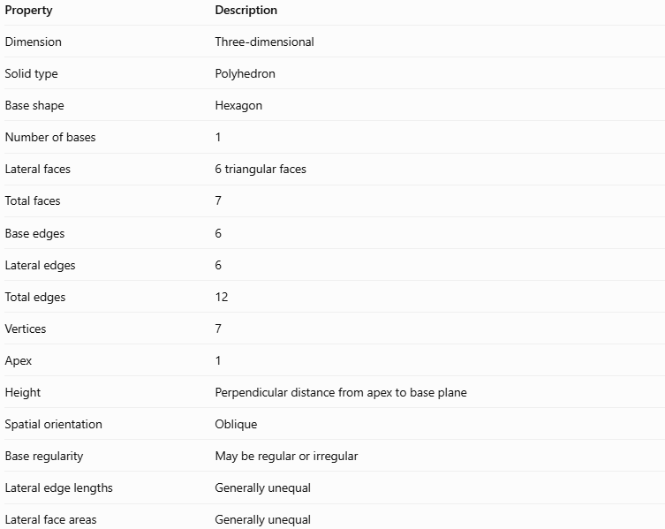
Property | Description
Dimension | Three-dimensional
Solid type | Polyhedron
Base shape | Hexagon
Number of bases | 1
Lateral faces | 6 triangular faces
Total faces | 7
Base edges | 6
Lateral edges | 6
Total edges | 12
Vertices | 7
Apex | 1
Height | Perpendicular distance from apex to base plane
Spatial orientation | Oblique
Base regularity | May be regular or irregular
Lateral edge lengths | Generally unequal
Lateral face areas | Generally unequal
The oblique orientation does not change the number of faces, edges, or vertices. It changes how the apex is positioned relative to the base.

Geometric Representation
# Source: AI Source: Provided by: [Data Path: Persons Table -> ID Column: 1, Name_En Column: Motasem Essam] -> From: [ChatGPT] on [7/25/2026]
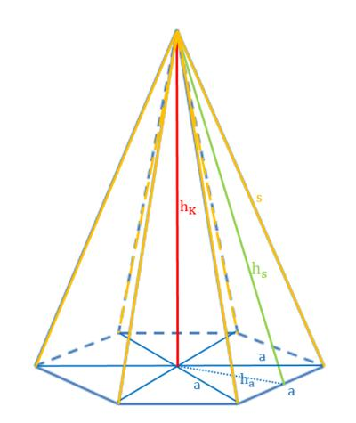
The main components are:
- Hexagonal base: The six-sided polygon forming the bottom of the pyramid.
- Apex: The point where the six triangular lateral faces meet.
- Base edges: The six edges around the hexagonal base.
- Lateral edges: The six sloping segments connecting the apex to the base vertices.
- Lateral faces: The six triangular surfaces joining the apex to the six base edges.
- Perpendicular height ($h$): The perpendicular distance from the apex to the base plane.
- Foot of the height: The point where the perpendicular height meets the base plane. It is generally not at the designated center of the base.
- Slant heights: The perpendicular altitudes of the individual triangular faces. They are not necessarily equal.

Mathematical Representations and Formulas
# Source: AI Source: Provided by: [Data Path: Persons Table -> ID Column: 1, Name_En Column: Motasem Essam] -> From: [ChatGPT] on [7/25/2026]
Let:
- $s_{i}$ = length of the $i$-th base edge
- $p$ = base perimeter
- $B$ = base area
- $h$ = perpendicular height
- $A_{i}$ = area of the $i$-th lateral face
- $l_{i}$ = perpendicular altitude of the $i$-th lateral face
- $A_{L}$ = lateral surface area
- $A_{T}$ = total surface area
- $V$ = volume

A. Base perimeter
# Source: AI Source: Provided by: [Data Path: Persons Table -> ID Column: 1, Name_En Column: Motasem Essam] -> From: [ChatGPT] on [7/25/2026]
For a hexagonal base:
$$\boxed{p=\sum_{i=1}^{6}{s_{i}}}$$
The perimeter is the sum of the six side lengths. If the base is irregular, the sides cannot generally be represented by one common length.

B. Base area
# Source: AI Source: Provided by: [Data Path: Persons Table -> ID Column: 1, Name_En Column: Motasem Essam] -> From: [ChatGPT] on [7/25/2026]
For an irregular hexagonal base, divide the polygon into simpler shapes, such as four triangles, and add their areas:
$$\boxed{B=A_{1}+A_{2}+A_{3}+A_{4}}$$
Alternatively, use the coordinates of the six vertices with the shoelace formula.
For a regular hexagonal base with side length $a$:
$$\boxed{B=\frac{3\sqrt{3}}{2}a^{2}}$$

C. Volume
# Source: AI Source: Provided by: [Data Path: Persons Table -> ID Column: 1, Name_En Column: Motasem Essam] -> From: [ChatGPT] on [7/25/2026]
The volume of an oblique hexagonal pyramid is:
$$\boxed{V=\frac{1}{3}Bh}$$
The height $h$ must be perpendicular to the base plane. Do not substitute the length of a lateral edge for the height.

D. Lateral surface area
# Source: AI Source: Provided by: [Data Path: Persons Table -> ID Column: 1, Name_En Column: Motasem Essam] -> From: [ChatGPT] on [7/25/2026]
The lateral surface area is the sum of the six triangular face areas:
$$A_{L}=\sum_{i=1}^{6}{A_{i}}$$
Since each triangular face has area $\frac{1}{2}$ times its base edge times its perpendicular altitude:
$$\boxed{A_{L}=\frac{1}{2}\sum_{i=1}^{6}{s_{i}}l_{i}}$$
For an oblique pyramid, a single common slant height usually cannot be used for all six faces.

E. Total surface area
# Source: AI Source: Provided by: [Data Path: Persons Table -> ID Column: 1, Name_En Column: Motasem Essam] -> From: [ChatGPT] on [7/25/2026]
$$\boxed{A_{T}=B+A_{L}}$$
This includes the hexagonal base and all six triangular lateral faces.

F. Euler's formula
# Source: AI Source: Provided by: [Data Path: Persons Table -> ID Column: 1, Name_En Column: Motasem Essam] -> From: [ChatGPT] on [7/25/2026]
For a convex hexagonal pyramid:
$$V_{e}-E+F=2$$
$$7-12+7=2$$
The oblique orientation does not affect this relationship.

Worked Examples
# Source: AI Source: Provided by: [Data Path: Persons Table -> ID Column: 1, Name_En Column: Motasem Essam] -> From: [ChatGPT] on [7/25/2026]
Example 1: Counting faces, edges, and vertices
An oblique hexagonal pyramid has six sides on its base.
- Faces: $6+1=7$
- Edges: $6+6=12$
- Vertices: $6+1=7$
Therefore, it has 7 faces, 12 edges, and 7 vertices.
Example 2: Calculating volume
Suppose an oblique hexagonal pyramid has a base area of $72{\text{ cm}}^{2}$ and a perpendicular height of $9\text{ cm}$.
Using the volume formula:
$$V=\frac{1}{3}Bh$$
Substitute the values:
$$V=\frac{1}{3}\left(72\right)\left(9\right)$$
$$\boxed{V=216{\text{ cm}}^{3}}$$
Even though the pyramid is inclined, the volume formula remains unchanged.
Example 3: Calculating lateral and total surface area
Suppose the six triangular lateral faces have the following areas:
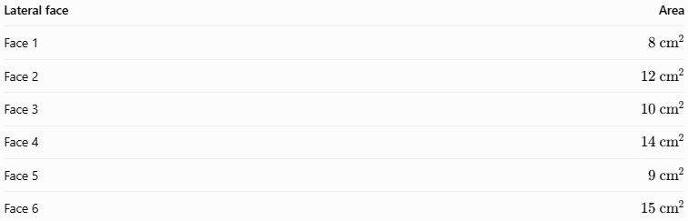
Lateral face | Area
Face 1 | $$8{\text{ cm}}^{2}$$
Face 2 | $$12{\text{ cm}}^{2}$$
Face 3 | $$10{\text{ cm}}^{2}$$
Face 4 | $$14{\text{ cm}}^{2}$$
Face 5 | $$9{\text{ cm}}^{2}$$
Face 6 | $$15{\text{ cm}}^{2}$$
Add the six face areas:
$$A_{L}=8+12+10+14+9+15$$
$$\boxed{A_{L}=68{\text{ cm}}^{2}}$$
If the base area is $72{\text{ cm}}^{2}$, then:
$$A_{T}=B+A_{L}$$
$$A_{T}=72+68$$
$$\boxed{A_{T}=140{\text{ cm}}^{2}}$$

Comparison with Related Concepts
# Source: AI Source: Provided by: [Data Path: Persons Table -> ID Column: 1, Name_En Column: Motasem Essam] -> From: [ChatGPT] on [7/25/2026]
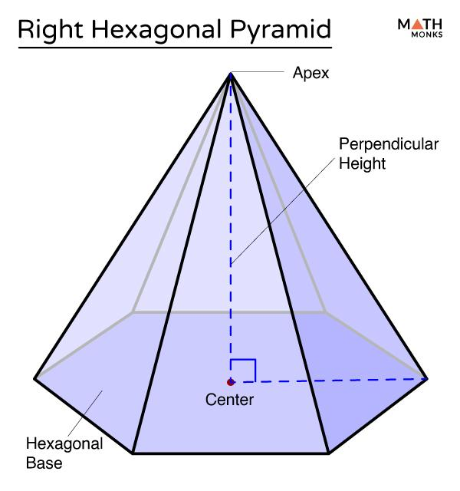
Right Hexagonal Pyramid
Its apex lies directly above the designated center of the base, and its height is perpendicular to the base plane.
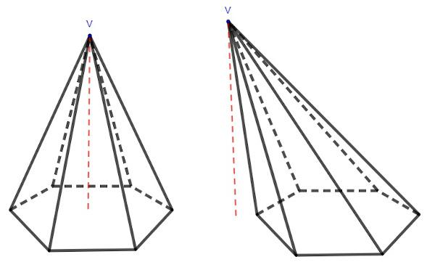
Oblique Hexagonal Pyramid
Its apex is offset from the designated base center, so the pyramid has an inclined arrangement.
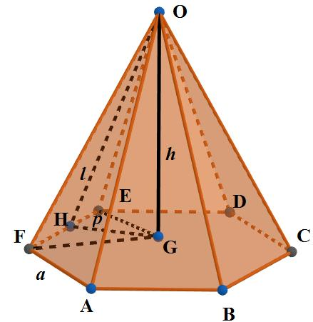
Regular Hexagonal Pyramid
It has a regular hexagonal base and a centered apex, giving it six congruent isosceles triangular faces.
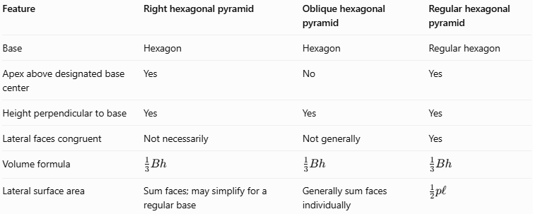
Feature | Right hexagonal pyramid | Oblique hexagonal pyramid | Regular hexagonal pyramid
Base | Hexagon | Hexagon | Regular hexagon
Apex above designated base center | Yes | No | Yes
Height perpendicular to base | Yes | Yes | Yes
Lateral faces congruent | Not necessarily | Not generally | Yes
Volume formula | $$\frac{1}{3}Bh$$ | $$\frac{1}{3}Bh$$ | $$\frac{1}{3}Bh$$
Lateral surface area | Sum faces; may simplify for a regular base | Generally sum faces individually | $$\frac{1}{2}pl$$
A regular hexagonal pyramid is a special case of a right hexagonal pyramid. A regular hexagonal base alone does not make a pyramid regular if its apex is offset from the base center.

Applications
# Source: AI Source: Provided by: [Data Path: Persons Table -> ID Column: 1, Name_En Column: Motasem Essam] -> From: [ChatGPT] on [7/25/2026]
- Architecture: Designing inclined roof structures and decorative pyramid forms.
- Product design: Creating asymmetrical display models and tapered packaging.
- Engineering: Modeling slanted components with polygonal bases.
- Computer graphics: Constructing asymmetric three-dimensional polygon meshes.
- Mathematics education: Demonstrating how apex position affects the shape without changing the general volume formula.

Key Points
# Source: AI Source: Provided by: [Data Path: Persons Table -> ID Column: 1, Name_En Column: Motasem Essam] -> From: [ChatGPT] on [7/25/2026]
- An oblique hexagonal pyramid has 7 faces, 12 edges, and 7 vertices.
- It has one hexagonal base and six triangular lateral faces.
- Its apex is offset from the designated center of the base.
- Its height is measured perpendicular to the base plane.
- Its lateral edges, slant heights, and face areas are generally unequal.
- Its volume is $V=\frac{1}{3}Bh$.
- Its lateral surface area is calculated by adding the areas of its six triangular faces.
- Oblique describes orientation, whereas regular and irregular describe the base and the pyramid's symmetry.

Conclusion
# Source: AI Source: Provided by: [Data Path: Persons Table -> ID Column: 1, Name_En Column: Motasem Essam] -> From: [ChatGPT] on [7/25/2026]
An oblique hexagonal pyramid is a polyhedron with a six-sided base and six triangular lateral faces meeting at an off-center apex. Its inclined geometry makes individual lateral face calculations important, but the basic counting relationships and volume formula remain the same as those for a right hexagonal pyramid. Understanding the distinction between perpendicular height and sloping edges is essential for accurate calculations.

